

MATHEMATICS 2CMAT/2DMAT SAMPLE EXAMINATION

RESOURCE-FREE
This sample examination paper was developed early in 2007 and distributed to all Mathematics teachers as part of the formal consultation process (April–May 2007). The purpose was to provide teachers with an example of how the course syllabus could be examined—specifically the scope, style and difficulty level of the questions that might be asked in a typical Mathematics 2C/2D WACE examination.

The sample paper has been further refined following consultation with teachers, measurement specialists and advice from the Assessment, Review and Moderation (ARM) panel. The major change is that the paper has been divided into two parts--a resource-free examination of 50 minutes, worth 40 marks, and a resource-rich examination of 100 minutes, worth 80 marks.

0000.doc




Western Australian Certificate of Education, Sample External Examination
Question/Answer Booklet

MATHEMATICS
2CMAT/2DMAT
Please place one of your student identification labels in this box.
WRITTEN PAPER
RESOURCE-FREE

Student Number: In figures

In words

Time allowed for this paper
Reading time before commencing work: Five minutes
Working time for paper: Fifty minutes

Material required/recommended for this paper

To be provided by the supervisor
This Question/Answer Booklet

To be provided by the candidate
Standard items: Pens, pencils, eraser, correction fluid, highlighter

Important note to candidates
The standard items listed above and the Resource-free examination paper are the only items permitted on your table during the Resource-free examination. When directed, you will place all other items and the Resource-rich examination paper under your chair.

This paper is for students who have completed Units 2CMAT and 2DMAT as their last pair of units.
Structure of this paper

Working time | Number of questions available | Number of questions to be attempted | Marks
50 minutes | 6 | 6 | 40
 |  | [Total marks] | 40

This paper has SIX (6) questions. Attempt ALL questions.

Question | Marks
1 | 9
2 | 6
3 | 5
4 | 5
5 | 8
6 | 7
Total marks | 40

Instructions to candidates

1. The rules for the conduct of Curriculum Council examinations are detailed in the Student Information Handbook. Sitting this examination implies that you agree to abide by these rules.

2. Write your answers in the spaces provided in this Question/Answer Booklet. Spare pages may be found at the end of the booklet. If you need to use them, indicate in the original answer space where the answer is continued (i.e. give the page number).

3. A blue or black ball point or ink pen should be used.

4. It is recommended that you do not use pencil except in diagrams.

5. Show all your working clearly. Your working should be in sufficient detail to allow your answers to be checked readily and for marks to be awarded for reasoning. Correct answers given without supporting reasoning may not be allocated full marks. Incorrect answers given without supporting reasoning cannot be allocated any marks. If you repeat an answer to any question, ensure that you cancel the answer you do not wish to have marked

RESOURCE-FREE

This paper has SIX (6) questions. Attempt ALL questions.

Question 1 [9 marks]
- Simplify:

4b – 2 [3b – (b+7)]
[2 marks]

- Solve the following equation algebraically, showing working:

(2a – 4)(a + 1) = 0
[3 marks]

- Show that 3k(3k – 1) = 4(4 – k) + k is equivalent to 9k² – 16 = 0
[2 marks]

- Use factorisation to solve 9k² – 16 = 0

[2 marks]

Question 2 [6 marks]

Describe a graphical method of solving the given equation. Provide a sketch as part of your answer.

– x² + 9 = 2x + 1
[6 marks]

Question 3 [5 marks]
A chemical spill killed many bream (a species of fish) in a river in the year 2004. The river was restocked by bringing 800 bream from another river. Before they were released, these fish were tagged.

- One year later, environmental officers netted 56 bream from the river, of which 7 had tags. The fish were then released back into the river. Estimate the population of bream in the river at this time.
[3 marks]

- What, if any, assumptions did you make in your answer to (a)?
[2 marks]

Question 4 [5 marks]
A triangle ABC is shown with vertices at: A(-1, 7), B(5, -3) and C(-3, -1).
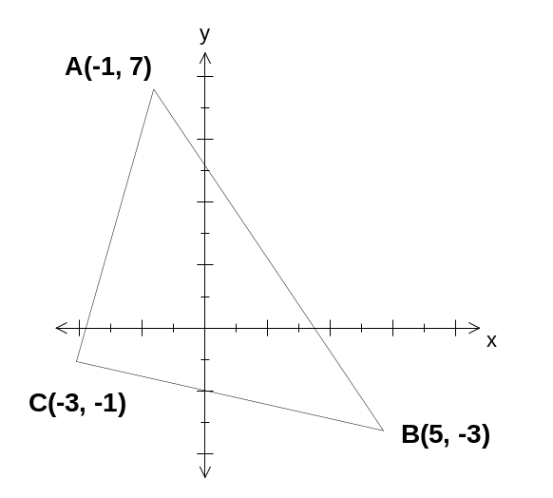

- Find the gradient of the line passing through A and B.
[2 marks]

- Determine the equation of the line that is perpendicular to the side AB and that passes through the point C.
[3 marks]

Question 5 [8 marks]
- For each of the following conjectures, state whether it is true or false.
- If it is true, give THREE (3) examples of when it is true.
- If it is false, give ONE (1) example of when it is false.

The set of counting numbers is {1, 2, 3, 4, …}.

- If n is an odd counting number greater than 1, then n² - 1 is a multiple of 8.
[2 marks]

- The product of two consecutive counting numbers is a multiple of 4.
[2 marks]

- Justify the claim that the sum of three consecutive numbers is always a multiple of 3.
[4 marks]

Question 6 [7 marks]
A group of 60 tourists to Western Australia were on a bus tour and discussed which places they intended to visit on later tours. Forty two tourists said that they intended to visit the Valley of the Giants and 25 said that they intended to visit Monkey Mia. Four said that they did not intend to visit either of these places.

- 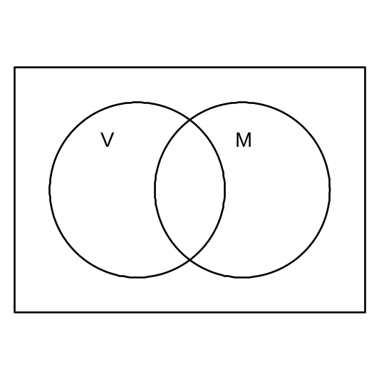Use the above information to complete the Venn diagram below.
[3 marks]

- (i) What is the probability that one of the tourists selected at random from those who intend visiting The Valley of the Giants also intends to visit Monkey Mia?
[2 marks]

(ii) What is the probability that one of the tourists selected at random from the whole group intends to visit Monkey Mia, only?
[1 mark]

(iii) Write the question in (ii) using probability notation.
[1 mark]

ACKNOWLEDGEMENTS

Published by the Curriculum Council of Western Australia
27 Walters Drive
OSBORNE PARK WA 6017

